**Level 7**

Baratieri vs. Gojjam forces led by *Nigus* Teklehaimanot

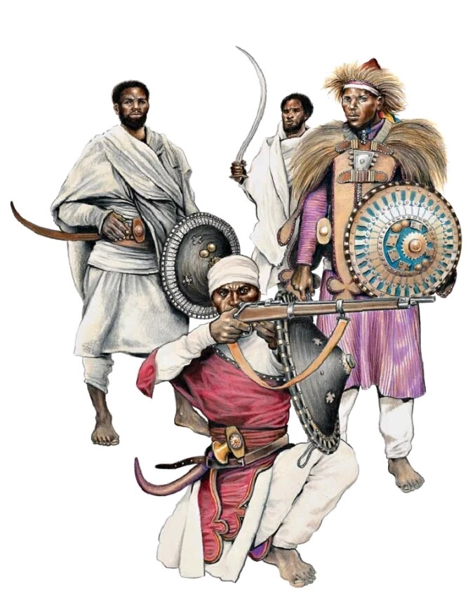

Prepared by:

1.Sentayehu

2.Bereket Gebremariam

3.Dawit Abraham

**Description of Architecture Views**

**What are the perspectives to describe the architectural views of the level?**

1. **Historical back ground**
2. **In fighting perspective**

The battle of Adwa can be called a meeting engagement, which is a type of offensive combat. It was a clash of troops of the two sides advancing toward each other. From the outset, both sides attempted to carry out the assigned missions by means of a strategic offensive.

Ethiopian force could imagine the Italians had sophisticated military training and technology (use of firearms), the strategic design undertaken by Menelik and his army lieutenants was focused on being engaged in conventional war a **fight of army against army in the open field**.

Though this strategy contributed to the **heavy loss of human resources** on both sides, it helped the Ethiopian army, at the Battle of Adwa to crush the Italian forces and score a decisive and spectacularly victory.

1. **In land mark perspective**

The time the war of Adwa came to an end the last two brigades under a Baratieri command were outflanked and destroyed At **Mount Belah**, by Ethiopian force.

1. **Time/sun light perspective**

Italians plan to attack at **night** time because of not to be detected by Ethiopians troops. Italians had sophisticated military technic and technology but Ethiopian forces fight was meeting engagement while they detected the enemy.

The last battle of adwa At Mt. Belah, b/n the last two remaining brigades of Italian troops under Baratieri command and Gojjam forces under Negus Tekele Hayemanot was come to an end **At noon**.

1. **Weather perspective**

The main struggle for Italian troops was the series of **circled mountains and the heavy rain.**

1. **Aftermaths perspective**

Ethiopia won a decisive victory over Italy at the Battle of Adowa in December 1895. During the battle, Menelik’s warriors attacked with a ferocity the Italians couldn’t have imagined. Taking hardly any prisoners, the victors of Battle of Adowa killed **289 Italian officers, 2,918 European soldiers and about 2,000 Askari** (Africans who fought on the side of Italians). Another 954 Italians troops were missing, **while 470 Italians and 958 Askari were wounded**. Some 700 Italians and 1,800 Askari fell into the hands of the Ethiopian troops.

1. **Architecture Views of the level**

It’s easy to describe and design the architecture view of the level from the above historical back ground and war perspectives.

**NB:** all the architectural views and description of the level is driven form the details in historical background section.

1. **Environment**:

**Place of the war**

* Open filed.
* Circled by Mount Belah and other mountains.

**Time/light and weather**

* After Midnight up to noon, (moon light, sun rising and sun overhead)
* Rainy weather at the morning.

**Sounds**

Few Additional sounds from other levels

* Random voice of a man in pain (wounded).
* Random voice of a desperate Italians.
* Random voice of a victory of Ethiopian.

**Others**

* A lot of wound and Dead solders both Italians and Ethiopians. (Randomly distributed)
* Burning spots and smokes

1. **Game play**

**Weapons:** Both traditional and modern guns (at 19 century) which are token from Italians.

**Traditional weapons as other levels.**

Swords, spear and shield old gun (one shot . one reload ”ቁመህ ተብቀኝ”)

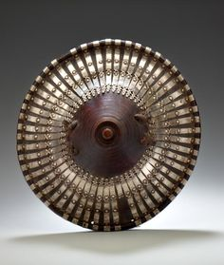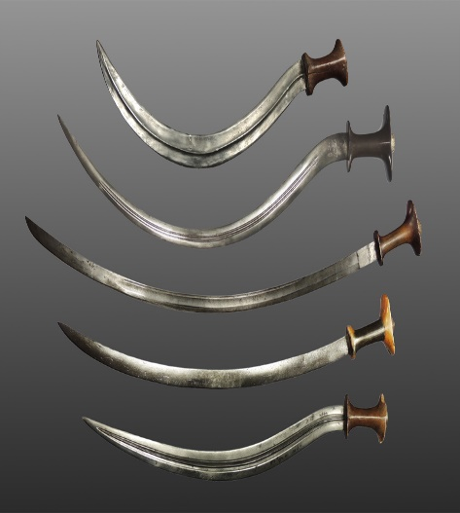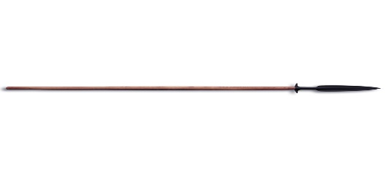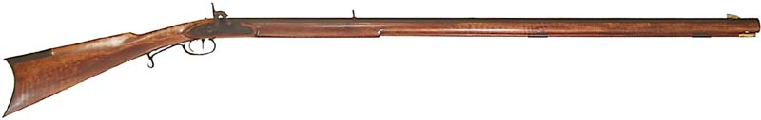

Fig: Traditional weapons and old gun

**Modern weapons.**

Classic guns one shoot and preload (ማቀባበል)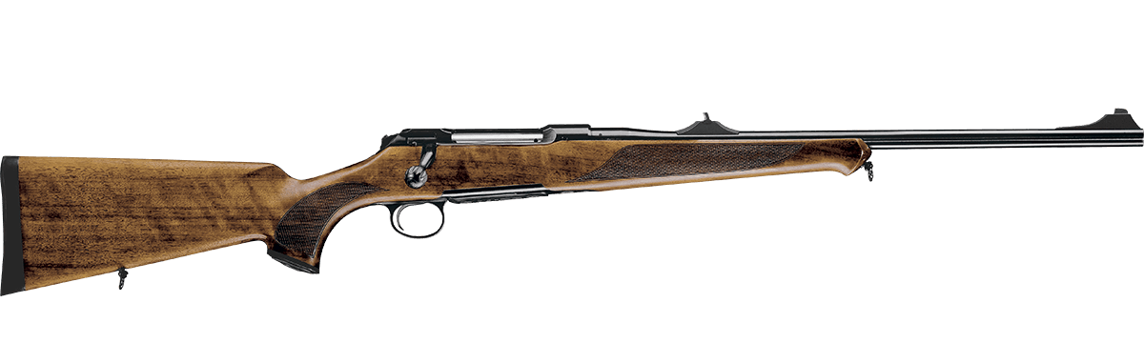

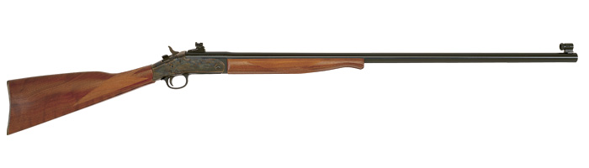

Fig: classic Guns

**NB:** At this level all the weapons used by both the player character and enemies are the same since the player captured Italians solder with they weapons in the previous levels.

**Game interaction**

**Weapon:** Once the character get a weapon it will store and change it by pressing a weapon changing key.

**Save:** The game auto save in the given sab-level. And if the mission field, on sub menu by pressing retry button it well automatically start from the last sab-level environment.

**Map:** The map in the level use to describe and locate geographical phenomena and ongoing events.

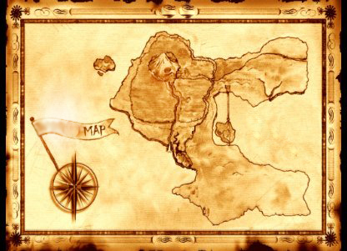

Fig: Map prototype.

**Game Mechanics (Graphics Perspective)**

**Overview**

This is the final stage of the battle of Adwa. At this stage the complexity of the game has to increase ; The reality is that most of the troops from Italy side are injured and surrendered and no much effort is expected to play against the Italians than level 6. we tradeoff between these and decided to include both in a customized way, how?

**Core game play**

**Environment:**

The landscape of “Mount Belah” is full of up and downs. During the war there is a rain and there also were tents around the mountain

**Introduction**

The game starts with the command of Nigus Teklehaimanot of Gojjam and some wounded warriors of Ethiopia. The king will tell his soldiers that the Gojjam people are brave as every Ethiopian are and orders to fight for their country .His message is as follows…

“እኛ ጎጃሜዎች ሁሌ ተከብረን ነው የኖርን:: ማንም ጠላት ደፍሮን አያውቅም፣አይደፍረንምም አሁንም ጦጵያን በጀግንነታችን አናሳፍራትም የሀገሬ ሰው ታጥቀህ ተነሳ !!! ”

The wounded soldiers will also make a speech for the peoples gathered not to forgive the Italians rather to chaise, surrender and invade them until the end of the war. They also tell the soldiers that they are wounded and prefer to die for their country as it is a pride for them.

During this time the whole sword will make a crowd voice and start “shelella” and “Kererto” and after 5 seconds later by the order of the king the soldiers will start to move to fight and defend the country into the battle.

The camera perspective will move to tents where the player is arrested and tortured. In the tent there are two Italian troops and the player. The player since he is tortured, his blood is seen on the ground, being his face bloody, his eyes injured, his head is kept down, his hands are arrested in the backward with the chair. When the Italians hear the echo of the crowd of the Ethiopian soldiers, they turn their heads to the source of the sound and one of them will get out of the tent and checks. After a while he comes back and tell the other guard that it is the Ethiopian soldiers and they get out to send telegram message to Barraiteri .This time the player will start to investigate his rooms and finally has to noticed the sharpy iron on the table near by. He then uses his right and left keyboard arrows to move his tables and finally get the sharpy iron. Finally he has to unlock his hand and has to hide to attack the Italian guards using this sharpy iron. If this is successful, he should take their weapon for his mission, otherwise the next step will be very challenging. This ends Checkpoint-1 and Checkpoint-2

After this the player should move out of the tent for his next mission. As he gets out there will be 5 Italian soldiers around “mount Belah” hiding. The player should kill them as fast as possible otherwise he will be attacked. If successful the game continues. On his way to tent to for invading the Italians he should get into the armament store for a bomb for his next Checkpoint to be successful, other wise he will easily be attacked and died. When he approaches the next Checkpoint he should throw the bomb and destroy the camp before the 10 Italians discover him. If successful he will continue to the next stage. This ends Checkpoint-3.

The last checkpoint will be the soldiers dinning camp, where soldiers gather to eat for lunch and dinner. The player must be inside the army to attack the large group of soldiers for this purpose he should dress like the Italian soldiers. In order to do this he has to either go back and change his clothe from the dead Italians soldiers or will be attacked easily. Changing the clothe will be done using the “Enter” keyboard key once approached the dead Italian from 0.5meter. The toxic object is given to him around 100 meters from the camp and using an arrow to show exactly where it is.

The dinning room will have wooden chairs, and around 20 soldiers.

After getting into the dinning camp slowly he should enter into the kitchen and use the some toxics to contaminate their food. If successful he could kill all the soldiers there and accomplishes the last session, checkpoint-4.After this the player will go back to celebrate his victory with his compatriots, with a military position award!

Graphical Representation

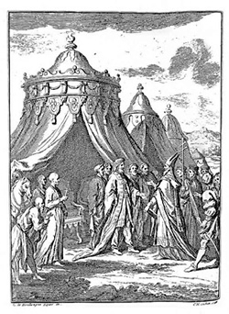The Ethiopian Kings The Italy soldiers

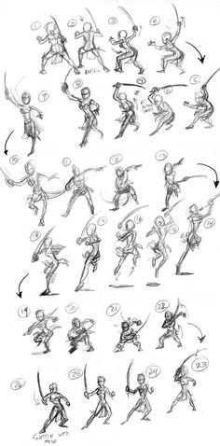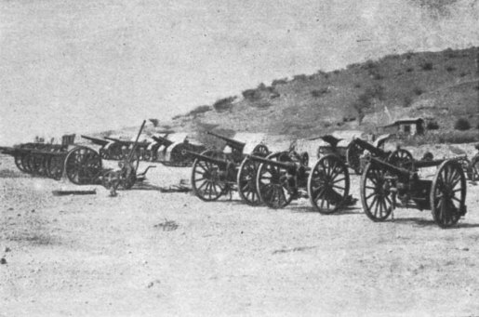

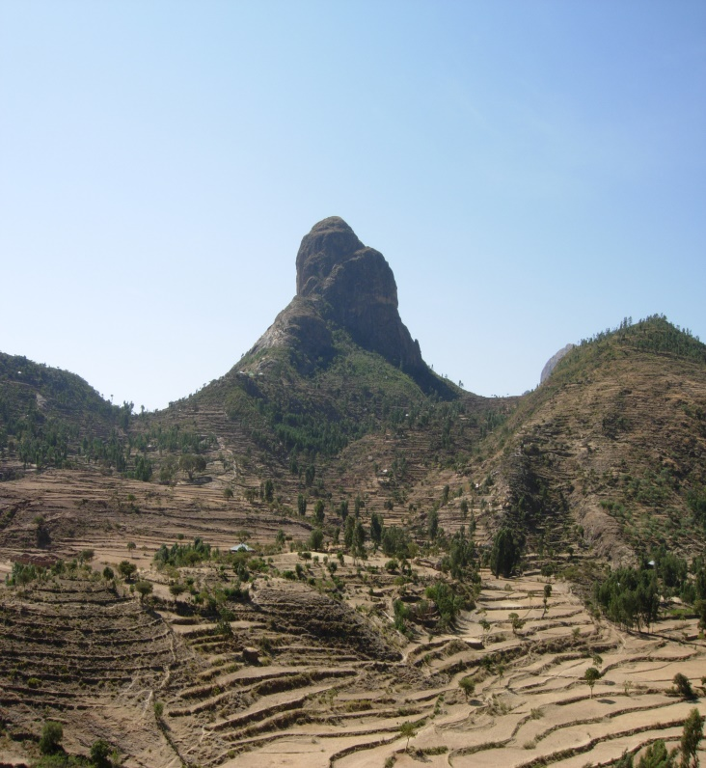

The Ethiopian soldiers Mount Belah

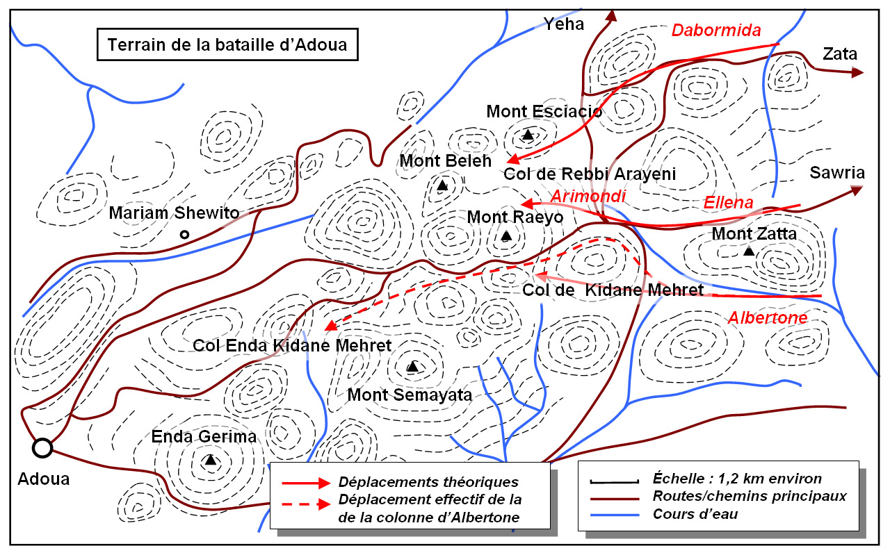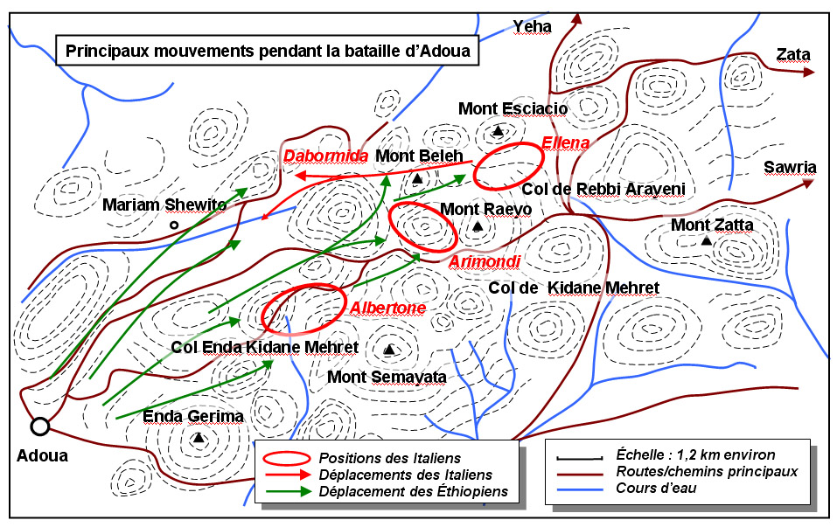

The detail map of the war and the Ethiopian soldiers movement

GAME FLOW DIAGRAM

START

Go to armament store

Get out of Tent

Get weapon

Wait

Unlock

YES FAIL

Dinning camp

Change dress

Bombard

Camp-2

Attack

Attack

FAIL 🡪CHECKPOINT-1

PASS

FAIL 🡪 CHECKPOINT-2

PASS

PASS

FAIL 🡪CHECKPOINT-3

PASS FAIL

contaminate

🡪CHECKPOINT-4 SUCCESS

MISSION ACCOMPLISHED

**Game session**

**START:**

The game starts from the place where the player was arrested and continues through out of the game using a total of four checkpoints.

**Did the player Activate:**

The player will start playing once he is activated otherwise no movement is allowed. To start the game any of the allowed arows will activate the player.

If the players health get low he will be activated using health meter. This will be accomplished with the corresponding keyboard key.

**Set status Active:**

Unless the player is injured he will be always be active during the checkpoints mentioned above. If injury happens he will be reactivated again using the health meter.

During different session of the story such as narration, the player stays inactive and activated again when the session finished.

**The Physics and statistics of the gaming**

**Running:**

When running on Straight Street there will be smooth travel. when an obstacle is faced the player will need to the direction arrows to change his direction accordingly. Otherwise a collision with these stones will case some vibration, loose of balance and failure. The player can use speed up and speed down mechanisms to achieve his goal.

**Jumping:**

When the barrier is faced or there is hole the player will be capable of jumping upto 0.5meter.This enable to pass different obstacles faced on the way.

**Game Mechanics**

The 7th Level of Adwa will require that the game player takes a stealthy approach rather than an aggressive one. It will include stages that require the player to sneak past guards or sneak up behind them and execute a sneak attack. It will encourage the player to use weapons that do not make loud noises such as his spear or sword. If the player is spotted by nearby enemy soldiers they will alarm other nearby soldiers which will set a very hard challenge for the player.

**4.1 Game Objects**

1. **Main Character:**
   1. Weapon Choices:

The player will have a choice of a Firearm, Spear and Sword. The choice will be handled by an event listener that will listen to the pressing of either 1, 2 or 3 keys on the number pad. The choice can also be made by rolling the middle mouse button.

Pseudo code

Listen for user input (1, 2, 3 or Middle Mouse Roll)

When listener is activated

Call for the weapon choice user interface

Change the active weapon to user’s choice

Close the Weapon choice interface

* 1. Sneak Attack

The player can sneak up behind an enemy and perform a special kind of attack to kill the enemy soldier silently.

Pseudo Code

While the player is within one meter of the enemy soldier

If the player is not spotted and if the player is behind the soldier

Display a sneak attack button (E)

If the player presses this sneak attack button (E)

Perform Sneak Attack (Call an animation of the sneak attack being performed.)

* 1. Spear Throw

If the player has his spear selected as the active weapon, he can throw it at distant enemy soldiers and kill them instantly. But his aim will have to be perfect or he will miss them and be spotted. When the enemy soldiers spot the player, they will alarm nearby soldiers and call for help.

Pseudo Code

While the Player has his spear selected

If the player presses the Action key (Left Mouse Button)

Display an aim circle at the crosshair that decreases its diameter.

If the player releases the action key before the diameter decreases to 0 and the circle disappears,

Throw the spear at a trajectory aimed at hitting a random point within the circle.

Remove the spear from the current weapons stack

If the spear hits an enemy soldier

Make a low volume sound (Range 3m)

The soldier dies instantly.

If the spear does not hit an enemy soldier

Make a high volume sound (Range 6m)

* 1. Spear Retrieval

If the player gets within 1m of a fallen soldier or spear

Display a perform action interface to pick up the spear

If the player presses perform action

Pick up the spear

Add it to the weapons stack

* 1. Sword Attack

While the Player has his Sword Selected

If the player presses the action button

A Strike with the Sword will be called

If the player hits a soldier, the player will get into fight mode with that soldier.

If the player is pressing the block key (Space)

The character will be shielded and won’t receive hard damage from enemy blows

If the player presses the attack key

The character will strike with the Sword hitting the enemy soldier who is in fight mode with the character

* 1. Firearm Attack

While the player has the firearm selected.

If the player presses the action key (Left Mouse Button)

The firearm is fired at a random spot from the circle surrounding the invisible cross hair with a diameter of 1m.

If the player presses the Aim Key (Right Mouse Button)

There will be an aim circle displayed at the cross hair.

If the player presses the Action Key (Left Mouse Button)

The firearm will be fired at the cross hair

The firearm will be reloaded with a call to a reload animation

* 1. Movement

The player can move around by pressing the following keys.

W (Front)

S (Back)

A (Left)

D (Right)

Space (Jump)

C (crouch)

Shift + W (Sprint)

Mouse (Rotate first person view)

E (Perform Action)

There will be an event listener for each of the above keys

As the player moves, he generates sound that is dependent on whether he crouching, standing or sprinting

Pseudo Code

If the player is crouching

Make a sound that ranges (0.5m)

If the player is walking

Make a sound that ranges (5m)

If the player is sprinting

Make a sound that ranges (10m)

1. **Enemy Soldiers**
   1. Patrol

Each enemy soldier will patrol a give surrounding.

Pseudo Code

While the enemy soldier is not alerted

Wait a random amount of time at a given location

Move to a random choice of a given set of patrol locations

* 1. Spotting The character

Set a field of sight according to the position of the enemy soldier

If the character enters this field

Alarm nearby soldiers by making a noise

Start attacking the main character

* 1. Attack Only two at a time

If the Main Character is already in fight mode with two other soldiers.

Stay in an attacking position facing the character but never attack

If a message is received about the death of a solder that was in fight mode with the character

Attempt to get into fight mode with the character

Else wait for another message (loop)

* 1. Hearing sounds

If the enemy soldier hears a sound nearby, he will go to the origin of that sound

Pseudo Code

When the soldier hears a sound

Get the location of that sound

Move soldier to that origin

Play a soldier curious animation

* 1. Looking at Dead Enemy Soldiers

When the enemy sees a dead soldier, he will panic and alarm nearby soldiers

Pseudo Code

If a dead soldier gets within the field of sight of the enemy

Play a panic animation

Alarm nearby Soldiers

* 1. Alarmed Soldier State

When a soldier is alarmed, his field of sight and the range of sound hearing will be widened

Pseudo Code

If soldier state is changed to Alarmed

Widen Field of sight

Widen Range of audible range

* 1. Level of difficulty of Attack

1. **Static Objects**
   1. Tents

Empty tents can hide the character from being seen by nearby soldiers

* 1. Camp Fires

The camp fires will incur a damage to any character who gets in contact with them

Pseudo Code

If a character (Player or soldier) collides with the fire object

Incur a damage at that character

**4.2 Game Object Data**

The Game Object Data specific to this level are

1. Enemy Solder State (Neutral, Alarmed, Spotted Character, Fighting Mode)

The soldiers can be in one of the 4 states.

**Neutral**:

When the soldier is patrolling the surrounding and has not spotted the character yet.

**Alarmed**:

If the soldier hears a sound and is spooked

**Spotted Character**:

If the soldier spots the character

**Fighting Mode:**

If the soldier is engaged in a fight with the character.

1. Main Character State (Neutral, Fighting Mode)

The main character has the following states he can be in

**Neutral**:

When the player is not fighitng and sneaking around

**Fighting Mode**:

When the player is engaged in a fight with a soldier